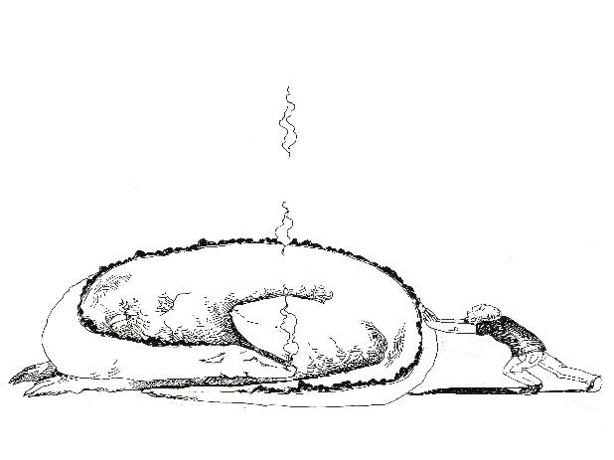

**WHAT TO DO WITH SLEEPING DRAGONS**

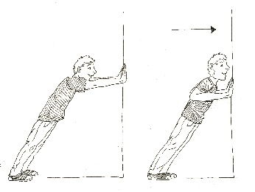**___________________________________________________**

1. 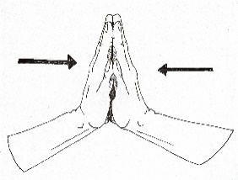**Wall Pushups**
2. 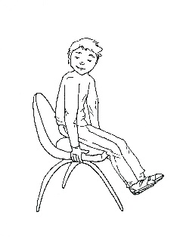**Push Hands Together**
3. 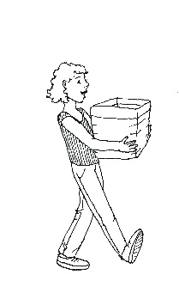**Chair Pushup**
4. 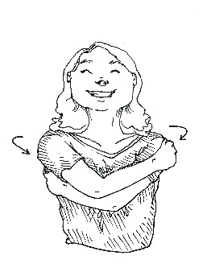**Heavy job**
5. 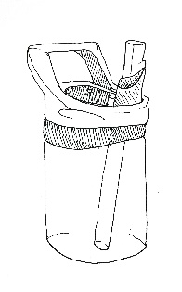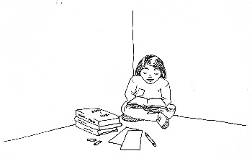**Big Hug**
6. 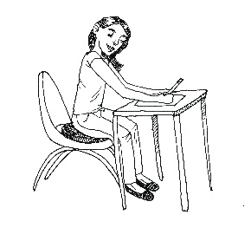**Drink of Water**
7. **Sit on a Cushion**