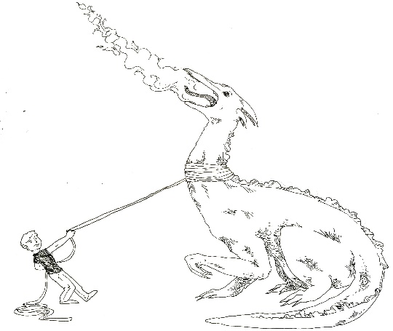**WHAT TO DO WITH FIRE DRAGONS**

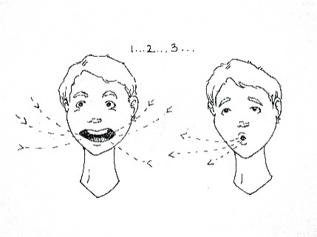**____________________________________________________**

1. 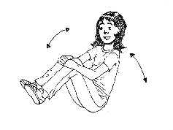 **Deep Breathing**
2. 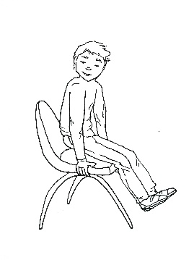**Slow Rocking**
3. 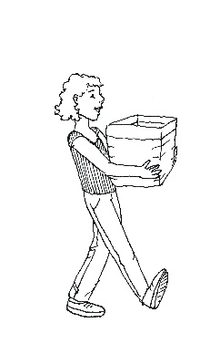**Chair Push-up**
4. 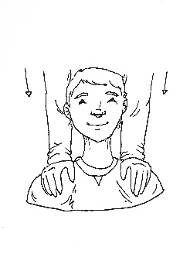**Heavy job**
5. 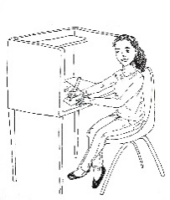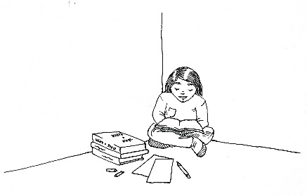**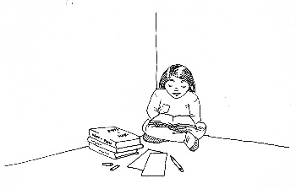Helper Squishes**
6. 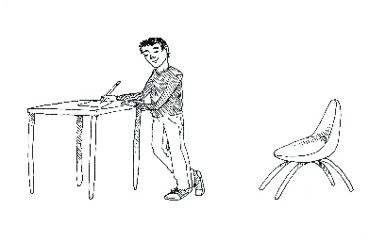**Quiet Work Place**
7. **Stand up or Move**